**The Fascinating World of Filipino Cuisine:** A Cultural and Culinary Odyssey

Written By : Abcedi Ilacas

December 3, 2023

1Photo from: <https://www.delightfultravellers.com/blog/best-street-food-to-try-in-manila-philippines>

Filipino cuisine, a vibrant culinary tradition, is a vivid tapestry woven from the Philippines' rich history and cultural diversity. Each dish tells its own story – of conquest, trade, and adaptation – reflecting the nation's multifaceted heritage. From the aromatic, bustling streets of Manila to the tranquil landscapes of the provinces, every morsel is a chapter of history, making Filipino food an endlessly captivating subject for culinary enthusiasts worldwide.

Imagine walking through the lively markets of Manila, where the air is fragrant with the scents of simmering adobo and fresh lumpia. It's here, amidst the chatter and clatter of pots and pans, that the true essence of Filipino cuisine comes alive, a blend of history and tradition served on every plate.

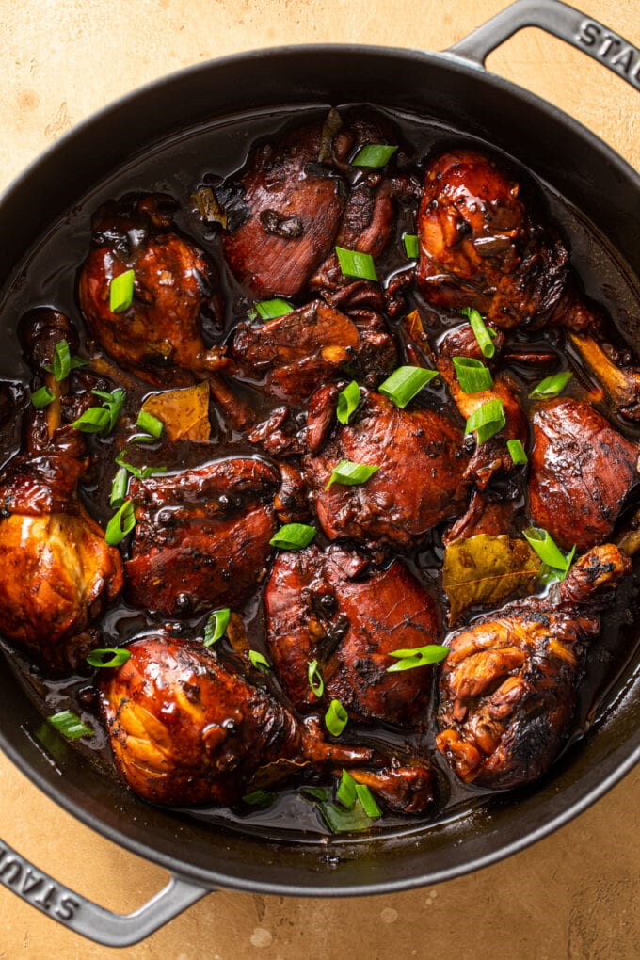At the heart of Filipino cuisine lies a melting pot of influences – indigenous, Spanish, Chinese, American, and other Asian and Western flavors. These diverse culinary strands have intertwined over centuries, creating a palate that captivates and delights. Growing up in the Philippines, I experienced this firsthand. Meals were an eclectic mix, from the sour tang of Sinigang, a testament to our indigenous roots, to the hearty Rellenos, echoing Spanish festivities.

My grandmother, a masterful storyteller in the kitchen, often cooked with a narrative, weaving tales of our history into each recipe. As she prepared Adobo, she'd recount how our ancestors adapted their cooking methods under Spanish rule, transforming simple ingredients into a dish that now symbolizes Filipino resilience and adaptability.

2Photo from: <https://www.butterbeready.com/chicken-adobo-filipino-style/>

The typical Filipino meal is a kaleidoscope of this rich cultural tapestry. It's not just the balance of sweet, sour, salty, and occasionally spicy flavors that defines our cuisine; it's the stories behind these dishes. Each meal is a celebration of our history, a reflection of a past that has shaped our present.

3Photo from: <https://www.thefooddictator.com/the-hirshon-filipino-roast-pig-cebu-lechon/>

The Spanish influence on Filipino food is the most profound, with Spain's nearly 400-year colonial rule leaving an indelible mark on the cuisine. Historians estimate that up to 80% of Filipino dishes have Spanish origins, a legacy that is evident in the names and flavors of numerous popular dishes. From festive fares like Relleno and Morcon to everyday staples like Adobo and Lechon, Spanish influence has shaped the culinary preferences and practices of Filipinos. This influence extended to the Filipino upper class, who adapted these dishes to create a fusion cuisine that is distinctively Filipino yet steeped in Spanish tradition.

4Photo from: <https://omnivorescookbook.com/lumpia-shanghai/>

The Chinese impact on Filipino cuisine is evident in the popularity of noodle dishes, a staple in many Filipino celebrations. Dishes like Pancit Canton and Lumpia Shanghai are direct results of Chinese trading and settlement in the archipelago. Additionally, Southeast Asian influences, particularly from neighboring countries like Indonesia and Malaysia, are visible in the use of chili and coconut milk in certain regional cuisines, such as those from the Bicol region. These influences display the adaptability and openness of Filipino cuisine to external culinary practices.

In recent years, Filipino cuisine has seen a surge in global popularity, thanks to a combination of factors including cultural appreciation, the impact of social media, and the creativity of Filipino chefs. Dishes like Adobo and Halo-Halo are becoming staples in cities across the world, signifying a growing international recognition. This trend is further fueled by Filipino chefs and restaurateurs who are introducing innovative interpretations of traditional dishes, making them more palatable to a global audience.

As global health consciousness rises, Filipino cuisine is undergoing a transformative journey, adapting its rich culinary traditions to fit healthier lifestyles. This evolution is not just a trend but a reflection of the dynamic nature of Filipino food. Traditional recipes are being reimagined with a focus on health, incorporating leaner proteins, reducing the use of salt and sugar, and emphasizing the use of fresh vegetables and whole grains. Dishes like Adobo, traditionally made with pork or chicken, are now also being prepared with healthier alternatives like tofu or seafood, maintaining the classic flavors while offering healthier benefits. The traditional sour soup, Sinigang, typically laden with tamarind and pork, is being reinvented with fish or shrimp, infusing the dish with omega-3 fatty acids, crucial for heart health. This health-oriented shift in Filipino cuisine is not only making these beloved dishes more accessible to health-conscious individuals but also highlights the cuisine's versatility and adaptability to contemporary dietary trends and preferences.

5Photo from: <https://usa.inquirer.net/131468/thousands-expected-at-torontos-taste-of-manila-aug-19-20>

The exploration of Filipino cuisine is a journey through a rich tapestry of history, culture, and flavor. It is a cuisine that tells the story of a nation's past and its journey into the future. As Filipino dishes traverse the globe and evolve with health trends, they carry with them the essence of the Philippines—a nation resilient, adaptable, and vibrant. This culinary journey is not just about discovering new flavors or recipes; it is about understanding how each dish reflects the Filipino spirit, its struggles, and its triumphs. Filipino cuisine, in its traditional form or healthier adaptations, offers more than just nourishment; it provides a window into the soul of the Philippines. For food enthusiasts around the world, delving into Filipino cuisine is an opportunity to experience the warmth, hospitality, and rich cultural heritage of this unique archipelago. Each dish, whether a hearty Adobo or a refreshing Halo-Halo, is an invitation to explore and celebrate the diverse and dynamic character of Filipino culinary art.

6Photo from: <https://www.seattletimes.com/life/food-drink/a-filipino-christmas-celebration-food-family-and-plenty-of-cheer/>

References

Ng, G. (2023, June 9). *Devouring Delightful Filipino Delicacies: An Exhilarating Expedition Towards Healthier Cuisine. Medical Channel Asia.*

Retrieved from <https://medicalchannelasia.com/devouring-delightful-filipino-delicacies-an-exhilarating-expedition-towards-healthier-cuisine/>

Kruse, N. (2022, November 7). *Filipino Cuisine Finally Gets Its Day in the Sun.*

Retrieved from <https://www.restaurantbusinessonline.com/food/filipino-cuisine-finally-gets-its-day-sun>

*The Rising Trend of Filipino Cuisine: A Flavorsome Journey Ahead.* (2023, June 8).

Retrieved from [https://www.in-withthenew.com/post/the-rising-trend-of-filipino-cuisine-a-flavorsome-journey-ahead](https://www.in-withthenew.com/post/the-rising-trend-of-filipino-cuisine-a-flavorsome-journey-ahead )

*Spanish Influence on Filipino Food.* Retrieved from <https://filipinokastila.tripod.com/Food.html>

Images

Delightful Travellers. (n.d.). *Best street food to try in Manila, Philippines.* Retrieved from <https://www.delightfultravellers.com/blog/best-street-food-to-try-in-manila-philippines>

Butter Be Ready. (n.d.). *Chicken Adobo - Filipino Style.* Retrieved from [https://www.butterbeready.com/chicken- adobo-filipino-style/](https://www.butterbeready.com/chicken-%09adobo-filipino-style/)

The Food Dictator. (n.d.). *The Hirshon Filipino Roast Pig - Cebu Lechón.* Retrieved from <https://www.thefooddictator.com/the-hirshon-filipino-roast-pig-cebu-lechon/>

Omnivore's Cookbook. (n.d.). *Lumpia Shanghai.* Retrieved from <https://omnivorescookbook.com/lumpia-shanghai/>

Inquirer.net USA. (n.d.). Thousands expected at Toronto’s Taste of Manila Aug 19-20. Retrieved from <https://usa.inquirer.net/131468/thousands-expected-at-torontos-taste-of-manila-aug-19-20>

The Seattle Times. (n.d*.). A Filipino Christmas celebration: Food, family, and plenty of cheer.* Retrieved from <https://www.seattletimes.com/life/food-drink/a-filipino-christmas-celebration-food-family-and-plenty-of-cheer/>